For this assignment, I created a sidebar UI element that has different options for a user to select. I plan on incorporating this UI setup for my personal VR game in the form of a popup the player can see on a miniature computer screen. The computer screen will allow the player to see different parts of my experience and create either powerups or harmful elements in the area they’re watching based on which UI element they select  
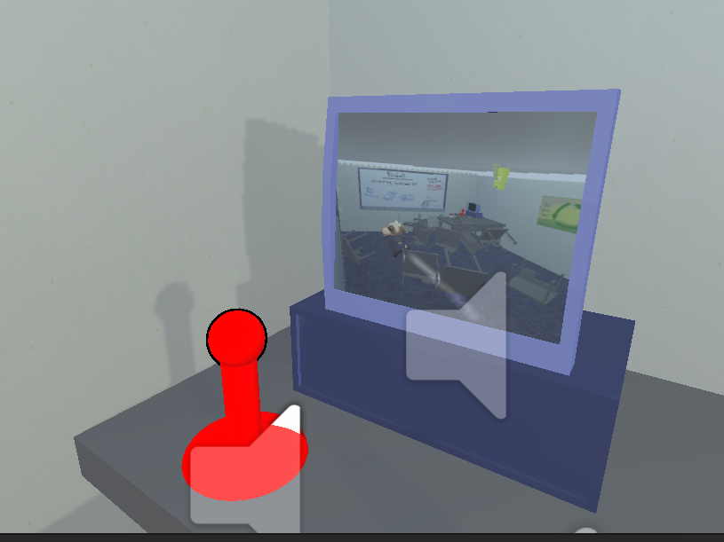  
My main concern with this setup is that is trying to find a good balance between the UI element taking too much or too little space onscreen. On one hand, the computer is naturally pretty small so I’ll need to increase its size somewhat. On the other hand, making the UI element too big will render the usability of this computer (to see different areas of the experience) useless since the UI element will take up too much space to use it appropriately. I’ll have to cross that bridge when I get there.   
  
This UI element features a title as well as different options you can press. I decided to make the images be visual elements / I think divs for web development since I don’t expect VR players to reach towards their computer screen and press the button. Unfortunately, I don’t think psuedos classes are fully supported for visual elements since the hover effect only works for the first child of the group and no active selectors work. Regardless, this UI element should be dynamic enough so that if you add a new type of thing the player can choose from, itll seamlessly update the size of the existing elements as long as you assign the correct stylesheets.  
  
I don’t have a distinct artistic style for my personal VR game beyond my personal style which I lack the vernacular or knowledge to describe, so I tried to style the UI elements akin to a Windows XP toolbar. Since this game takes place during the early 2000s, I think this style makes sense. The only thing I worry about is that the UI element will look out of place. There will be a camera view of the environment 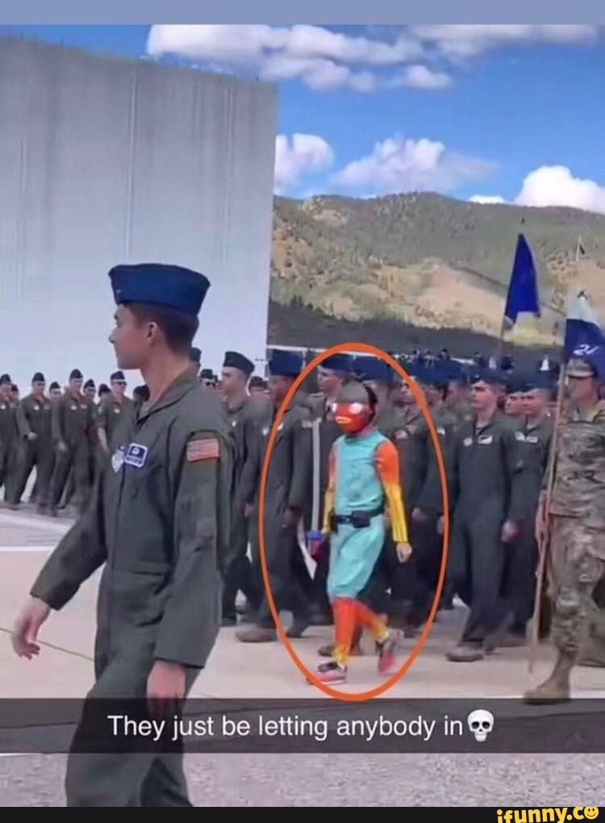you’re looking at and then a nondiagetic UI view in the corner, which I think will look ugly.

I think an easy fix for this is to make the computer screen look a lot more like a windows XP background but have the camera view in a separate tab that makes it look apart of the computer. I don’t think I will go that route due to time and scope restrictions, but I would imagine that could be a fun fix.